CurricuLab

The Student Centric Study Management System
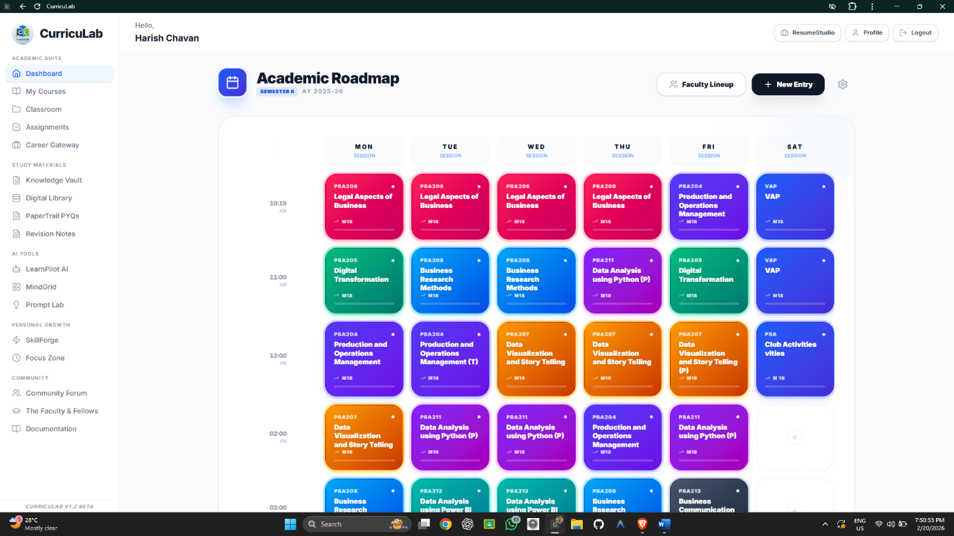

The Technical Team

Harish Ravindra Chavan
Code Base Manager and Core Developer

Kaustubh Nandurkar
APIs and Database Manager

Version 1.2 beta
Team Details

Harish Ravindra Chavan is the Student of MBABA, Sem-2 from Sandip University and for this project he is Code Base Manager and Core Developer, responsible for creating a frontend in order to convert the idea into the real product that fulfilling the all student’s expectations with easy to handle UI design contributing user friendly experience.
However, Kaustubh Khushal Nandurkar is also the Student of MBABA, Sem-2 from Sandip University and he is the APIs and Database Manager for this project, responsible for collecting different free API keys and connecting the frontend to the Backend using the database named ‘Supabase’ through its keys and SQL scripts(in order to create different tables).

Acknowledgement

The Special Thanks to the our teachers Dr. Zahir Shaikh and Dr. Samadhan Bundhe from Sandip University for their precious guidance and support. We are glad to have such guide or mentor who help us to review and evaluate the process continuously to avoid any neglection.

Under the Guidance of Dr. Zahir Sir, we have applied the various concepts of Business Research Methods, while under the Guidance of Dr. Samadhan Bundhe, we have applied the concept of Data Management and Warehousing along with SQL handling.

Table of Content

